

Beta radiation: deflection in a magnetic field

Demonstration
This focuses on the properties of beta particles. You can show that beta radiation is deflected in a magnetic field. This is an impressive and striking demonstration.

Apparatus and materials
- Geiger–Müller (G–M) tube
- Holder for G–M tube
- Scaler (if needed by G–M tube)
- Sealed pure beta source, strontium-90 (⁹⁰Sr), 5 μCi
- Large magnet (Eclipse major)
- Retort stands, bosses and clamps, at least 3
- G-clamps, 2
- Lead block
- Set of absorbers (e.g. paper, aluminium and lead of varying thickness)

Technical notes
Note that 5μCi is equivalent to 185 kBq.
G–M tubes are very delicate, especially if they are designed to measure alpha particles. The thin, mica window needs a protective cover so that it is not accidentally damaged by being touched.
You need to be especially careful handling the G–M tube near the Eclipse magnet, which is extremely strong. The magnet can pull the G–M tube out of a loose holder or even your fingers. Make sure that the G–M tube is firmly fixed in a retort stand, which is clamped to the bench before you start setting up the magnet.
Some education suppliers now stock all-in-one G–M tubes with a counter (e.g. Science Enhancement Programme).
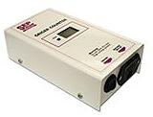
An all-in-one G–M tube and counter.
Education suppliers stock a set of absorbers that range from tissue paper to thick lead. This is a useful piece of equipment to have in your prep room. You can make up your own set. This should include tissue paper, plain paper, some thin metal foil (e.g. cigarette paper or the wrapping from a chocolate from an assortment box) and a small piece of gold leaf.
To cut off the direct path in step d, the lead block from the absorbers kit is just adequate, but a block with a bigger area is better.

Safety
This experiment puts the demonstrator at a small risk of receiving a dose of β radiation. The demonstrator should avoid leaning over the source and, if it cannot be avoided, should reduce the exposure time as far as possible. There are safer versions of doing this experiment that use a collimated beam and much smaller magnets.
Read our health and safety statement.

Procedure
a Use a G-clamp to secure one of the retort stands to a bench. Fix the G–M tube in its clamp. Point it up at an angle of about 30°.
b Secure a second retort stand to the bench and clamp the holder for the radioactive source in it. Again, face it up at an angle of about 30°.
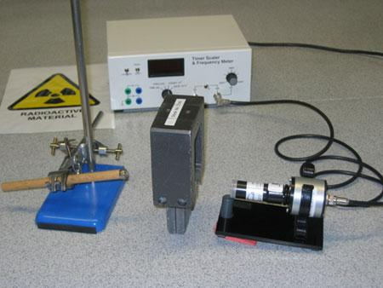
Photo courtesy of Mike Vetterlein.
c Place the large eclipse magnet on the lead block between the source and the G–M tube. Arrange it so that the source and the G–M tube are pointing into the middle of the space between its two poles. Take great care when handling the magnet near the G–M tube – it is very strong and can dislodge the tube if it’s not secure.
d Check that you can detect beta particles with the magnet in place (in one orientation). If the magnet is removed or turned round, you will not be able to detect beta particles. Make a note of which orientation works.
e Remove the magnet and return the beta source to the safe.

Carrying out
f Remove the magnet, place the sealed source in its holder and show that the lead sheet blocks all of the radiation. You can slide the lead in and out to show that beta radiation is being emitted and will reach the G–M tube.
g Put the magnet in place (the correct way) and show that the G–M tube is now detecting beta radiation. You can show this by using various shields next to the source and the tube.
h Rotate the poles of the magnet through 180° and show that this prevents the radiation from reaching the G–M tube.

Teaching notes
1 The beta radiation is deflected by the magnetic field. This suggests that it is made of moving charges.
2 With advanced students you may want to use Fleming's left-hand motor rule to identify the sign of the charge as negative.
3 The fact that the beta radiation is deflected by only a finite amount means that it must have mass. This suggests that it is a stream of (negative) particles. Students might suggest that it is made of electrons. You can say that further studies show this to be the case.
4 You might mention that alpha radiation is also deflected by a magnetic field, but not enough to measure with this equipment. It is deflected the other way, showing that it has a positive charge.
5 The absorption properties of beta radiation make it useful in industrial and some medical applications.
6 Experiments that deflect beta particles can measure their speed, which is about 98% of the speed of light. Thus relativistic effects cause an increase in the electrons’ mass.
7 Beta particles are formed when a neutron changes into a proton in the nucleus and the atom rises one place in the periodic table.
This experiment was safety checked in August 2007.

Related guidance notes

Managing radioactive materials in schools

Radioactive sources: isotopes and availability

Nature of ionising radiations

